SUMMARY OF CHAPTER 7 CONTINUATION III

ABSTRACTION:
Process of hiding the implementation details and showing only features needed.
Focus on what it does and not on how it does.
SYNTAX:
abstract class classname{
abstract void methodname();
void method() {
//statements
} }

EG:
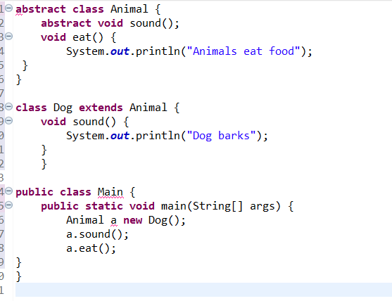
RULES:
we can’t create object for abstract class. Only sub class objects can be created.
If class has abstract method it should be declared as abstract.
Sub class must implement all the mentioned abstract methods.
Abstract class can have constructor, variable, normal methods.
DIFFERENCE BETWEEN INTERFACE AND ABSTRACT CLASSES
ABSTRACT CLASS:
abstract keyword is used.
Can have abstract and non abstract methods
Can have instance variables.
Multiple inheritance is not supported
Can have constructor
Uses extends keyword to access the methods.

INTERFACE:
Interface keyword is used.
Contains only abstract classes.
Contains constants such as public static final
Supports multiple inheritance
Cannot have constructor
Uses implements keyword to access the methods.

ADVANTANGES:
Data security
Code reusability
Improves flexibility
Simplified maintenance

EG of both abstraction and interface:
abstract class Student {
abstract void study();
void attendClass() {
System.out.println("Student is attending class");
}

interface Sports {
void play();
}

class CollegeStudent extends Student implements Sports {
void study() {
System.out.println("Student is studying");
}
public void play() {
System.out.println("Student is playing cricket");
} } }

public class sample {
public static void main(String[] args) {
CollegeStudent s= new CollegeStudent();
s.study();
s.attendClass();
s.play();
}
}

